Lesson 10
Installing FPP

Overview
Introduction |  | In this section, we will install the software we will use for programming the PIC hardware.
In this section |  | Following is a list of topics in this section:
 | Description |  | See Page
 | Downloading and Unpacking the Software |  | 2
 | Creating a Shortcut |  | 6
 | Cleaning Up |  | 7
 | Configuring FPP |  | 7
 | Testing FPP |  | 9
 | Testing the Programmer |  | 10
 | Wrap Up |  | 11

Downloading and Unpacking the Software
Introduction | In this section, we will get the software needed to program the PIC.
Downloading FPP | Begin by creating a directory to hold the zip files you will download. Also, create subdirectories to hold the contents of these files after you unzip them. These directories will eventually be deleted.  With your web browser, navigate to:  http://www.people.man.ac.uk/~mbhstdj/piclinks.html  Right-click on:  Select “Save Target As…” and navigate to the directory you just created. Save the zip file in that directory.
Unpacking FPP | Unzip the FPP software to the FPP subdirectory you created earlier. (See lesson 2 for the various approaches to unpacking these zip files).  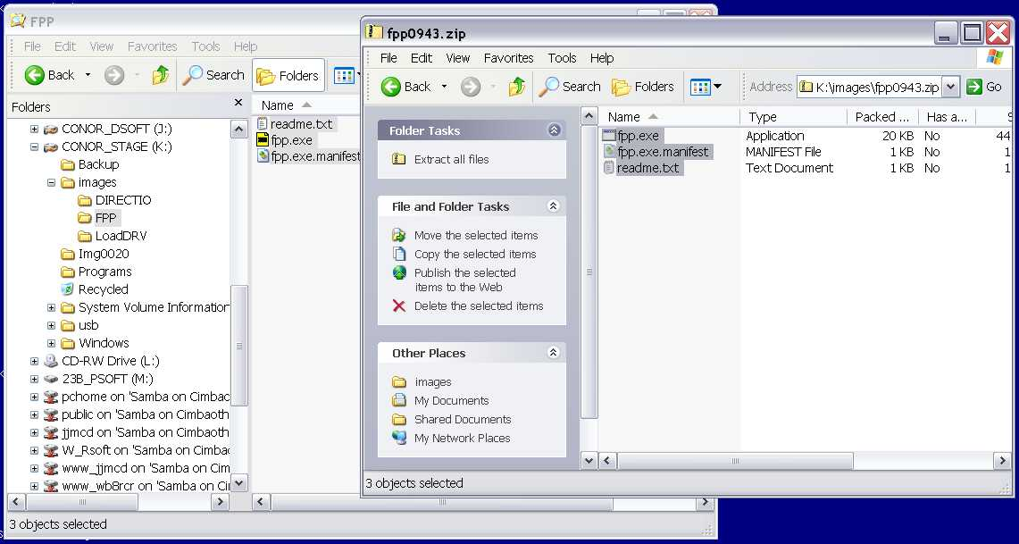  Create a directory where the FPP program will permanently reside (C:\Program Files\FPP isn’t such a bad choice).
 | Continued on next page
Downloading and Unpacking the Software, Continued
Unpacking FPP (continued) | All Windows® Versions except XP: Drag fpp.exe with the right mouse button to the directory you have selected as a final location. Select “Copy here” from the mouse menu.  Windows XP: Copy fpp.exe and fpp.exe.manifest to the final destination directory.  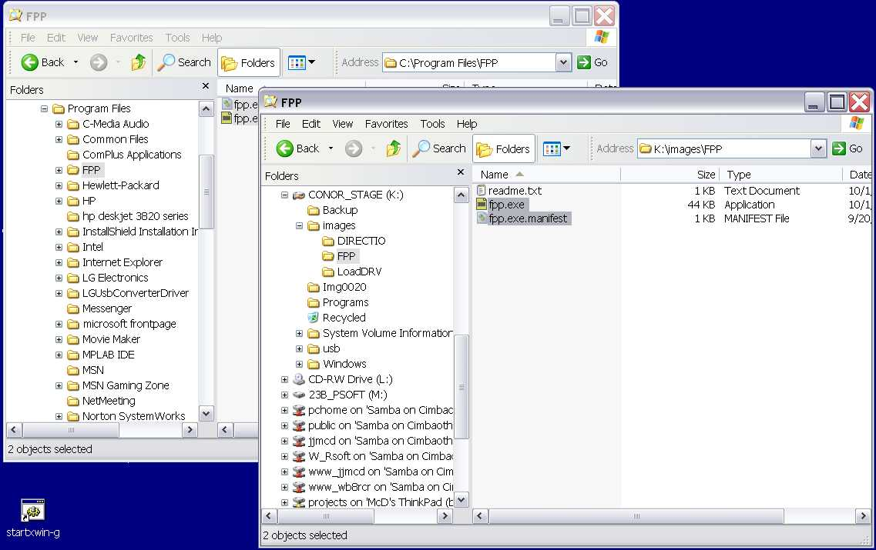  If you are using Windows 95/98/Me skip down to “Creating a Shortcut”.
Downloading DIRECTIO | The next few steps are only used for Windows NT® 4.0 and later (including Windows 2000 and Windows XP.)  DIRECTIO and LOADDRV are available on a number of places on the web. However, these links seem to be not very stable, so we have copied those files onto a server that we can keep stable for the duration of the course. Download the following two files into the same directory you created above:  http://www.zemanszoo.com/Elmer160/directio.zip  http://www.zemanszoo.com/Elmer160/loaddrv.zip
Unpacking DIRECTIO | Unzip the directio.zip file to the folder you have created for that purpose. Similarly, unzip loaddrv.zip.  Copy GIVEIO.SYS from the GIVEIO\I386\FREE folder into the folder where you copied fpp.exe. Similarly for LOADDRV.EXE. These are the only files actually needed from these two zip files.
 | Continued on next page
Downloading and Unpacking the Software, Continued
Installing GIVEIO | Double-click LOADDRV.EXE. Enter the full path name of GIVEIO.SYS into the text box. Click “Install”.  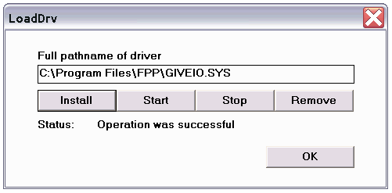  You should see “Operation was successful”. Now click “Start”. Again you should see “Operation was successful”. Close LOADDRV.  Reboot the computer.  Right-click “My Computer” and select “Properties”. Select the “Hardware” tab. Press the “Device Manager” button. From the Device Manager menu, select View->Show hidden devices.  Click on the plus sign to the left of Non-plug and Play Drivers and highlight GIVEIO.  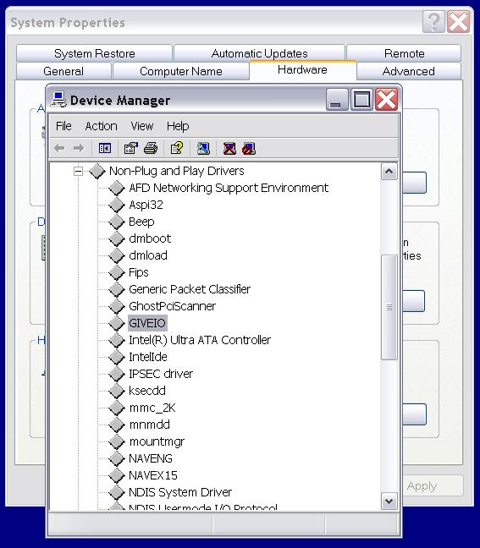
 | Continued on next page
Downloading and Unpacking the Software, Continued
Installing GIVEIO (continued) | Right-click on GIVEIO and select Properties from the menu. Select the Driver tab. In the startup type dropdown, select ‘Automatic’.  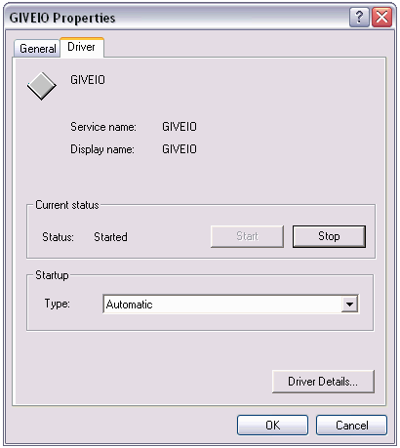  Click OK and close the system properties windows.

Creating a Shortcut (for all Windows versions)
Introduction | Now that we have the software installed, we need to create a way for us to use it easily. We could simply navigate to the directory where we installed FPP and double click fpp.exe. However, since we will be using FPP over and over again, it probably makes sense to create a convenient shortcut.  There are two places we might have a shortcut; on the desktop or on the Start menu. You may choose either, both, or neither, depending on your preference.
Creating a Desktop shortcut | A desktop shortcut allows quick access to a program all the time. However, if you already have a lot of shortcuts, it would be a problem to locate the shortcut among all the others.  If you have closed the Explorer window containing fpp.exe (the final one, not the original), open it again and navigate to that directory.  With the right mouse button, drag fpp.exe to the desktop. When you release the mouse, a menu will appear. Select “Create Shortcuts Here” from that menu.  Right-click on the newly created shortcut and select “Rename”. Change the name to FPP, PIC programmer, or whatever you would like the shortcut to be called.
Creating an item on the Start menu | If you have closed the Explorer window containing fpp.exe (the final one, not the original), open it again and navigate to that directory.  Open another Explorer window and navigate to the start menu:  Windows 9x:  C:\Windows\Profiles\usercode\Start Menu\Programs  Windows XP:  C:\Documents and Settings\usercode\Start Menu\Programs  This folder will contain an image of your start menu. Navigate down below Programs to the place on the start menu you would like your shortcut.  With the right mouse button, drag fpp.exe to the place you would like the menu item. When you release the mouse, a menu will appear. Select “Create Shortcuts Here” from that menu.  Right-click on the newly created shortcut and select “Rename”. Change the name to FPP, PIC programmer, or whatever you would like the shortcut to be called.

Cleaning Up
Introduction | We no longer need the installation files; everything we need to continue has been stored in our final directory.
Saving the Installation files | There is always a possibility that we want to reinstall some software, and when we do, it could be that the files we need are hard to find. At this time, it would be good to save the relevant zip files off to a floppy or CD:  fpp0943.zip  directio.zip (NT/W2K/XP only)  loaddrv.zip (NT/W2K/XP only)
Deleting the Directories | You can now delete the directory you stored the zip files in, and all the subdirectories where all the contents of the zip files were unpacked.

Configuring FPP
Introduction | Now that we have the software installed, we need to let FPP know where we intend to plug in our programmer, and what kind of programmer we have.
Finding the port address | Open the device manager. For NT/W2K/XP you did this earlier. For Windows 9x, right click on “My Computer”, select “Properties”, and click on the “Device Manager” tab.  Click on the plus sign to the left of “Ports (COM & LPT)”.  Highlight the port of interest, right-click, and select “Properties”. Select the “Resources” tab:  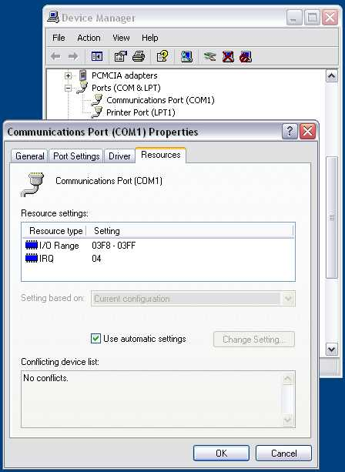
 | Continued on next page
Configuring FPP, Continued
Finding the port address (continued) | The “I/O Range” is the number of interest. This needs to be a standard address for FPP to work. For the PIC-EL, you should have selected a serial port. For a serial port, the valid values are 03F8-03FF or 02F8-02FF. For a parallel port (which will not work with the PIC-EL) the value should be 0378-037F, 03BC-03BF, or 0278-027F.  Write down the first number of the range for the port selected.
Setting the FPP Address | Double-click on the desktop shortcut you created or select FPP from the start menu item you created.  Click on the ‘Setup’ button.  From the “Hardware” dropdown, select SERPIC (for the PIC-EL).  From the “on port” dropdown, select the port with the address you wrote down above.  From the “Device” dropdown, select 16F84.  Click OK.  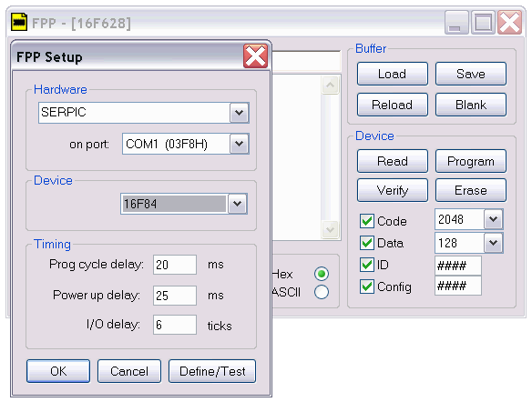

Testing FPP
Introduction | Now that we have FPP set up, we would like to test it. The following procedure applies to the serial port setup for the PIC-EL. You may test the setup for other programmers in a similar way, but the steps will not be precisely as outlined below.  You will need a voltmeter and a serial cable. Getting at the pins on the little 9 pin connector can be a bit of a challenge, so if you have some kind of breakout box or other device that will ease making voltage readings it could be helpful. If you haven’t installed it yet, the DB9 from your PIC-EL works well. Once it’s in place, though, you can’t reach some of the pins.
Entering the test mode | In FPP, click on the Setup button.  Click on Define/Test in the setup dialog. Connect the negative lead of your voltmeter to pin 5 of the serial connector. Connect the positive lead to pin 4. The voltage reading should be positive.  Click the ‘Apply’ button and check the “Enable” box. The voltage should not change.  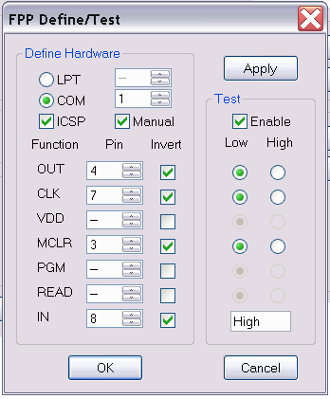  On the top row of radio buttons (next to “OUT”), click on the right (“High”). The voltage should go negative. Click on the left button (“Low”), the voltage should return to a positive voltage. (The value of the voltage should be between 9 and 15 volts.)  Move the positive lead to pin 7. Repeat the experiment with the next row of radio buttons (CLK).  The third row of radio buttons (VDD) should be grayed out.  Move the voltmeter to pin 3, and repeat the test with the fourth row of buttons (MCLR).  Click Cancel, Cancel.

Testing the Programmer
Introduction | In this section, we will use the FPP software to validate that we can communicate properly with the PIC programmer (or the PIC-EL).
Setting up | Remove any PIC from the programmer. Connect the programmer to the PC with an appropriate cable. (This test will work the same whether the programmer is a PIC-EL or another serial or parallel programmer). Apply power to the programmer and connect the negative lead of the voltmeter to the programmer’s ground.
Testing the data and clock lines | Start up FPP, click on Setup the Define/Test. If the programmer has a program switch, set it to program mode. On the PIC-EL, the programming LED should light.  Measure the voltage at PIC pins 12 and 13. Each should be below one volt.  Click on the Apply button and check the Enable box. The voltages at pins 12 and 13 should not change.  Click on the radio button on the right of the top row. PIC pin 13 should go high (approximately¹ 4 volts). Pin 12 should remain low. Click on the radio button to the right of the second row. Pin 12 should go high. Click on the left button on the top row. Pin 13 should go low and pin 12 should remain high.
Testing !MCLR | Measure the voltage on pin 4 of the PIC. The voltage should be approximately zero. Click on the right hand radio button in the fourth row. The voltage on pin 4 should change to approximately 12 volts.  If your programmer has a switch, set the switch back to run mode. (On the PIC-EL, the programming LED should extinguish.) The voltage on pin 4 should go to approximately 5 volts.  Click Cancel, Cancel, and close FPP.

¹ See table 9.2 in your PIC16F84A datasheet for a definitive (and confusing) definition of “approximate”.

Wrap Up
Introduction | In this lesson, we installed the FPP software we will use to load our programs into the PIC microcontroller. We used FPP and out voltmeter to test the installation, and to perform static tests on the programmer connections.
Coming Up | In the next lesson, we will write a program that begins to exercise parts of our test circuit, and we will use FPP to load the program into our PIC.

